**Programming for Computer Games**

**Question 1A:**

The two game engines I will be comparing are Unity3D and Construct 2. Both game engines are exceptional; however, Unity3D is better than Construct 2. The following four reasons will show you why Unity3D is better.

* **Reason 1:** Construct 2 does not export to native mobile code. Construct 2 only builds to HTML 5. This means that, depending on what HTML5 engine your mobile’s OS is using, there will be performance issues. On the other hand, Unity3D is a multiplatform software, which exports to almost all platforms and OS’s.
* **Reason 2:** Unity3D runs on, basically, all operating systems. However, Construct 2’s editor is Windows only. Even though Construct 2 is able to export to other Operating Systems, the main program is for Windows only.
* **Reason 3:** Money-wise, both software programs have a free version and a version that you would have to pay for. What you have to keep in mind is what the free version, for both software programs, offers. Unity3D’s free version offers everything you would need for a beginner's game with high quality. The difference between the free Unity3D and Unity3D Pro is that, just like it says, Unity3D Pro is for pro level users, mainly. On the other hand, Construct 2’s free version is limited compared to Unity3D. The content on the free version of Construct would be amateurish and low quality.
* **Reason 4:** Construct 2 has a really poor mobile performance. This is due to the fact that Construct 2 works with JavaScript, which is not as fast as native code. Meaning, poor mobile performance.

**Question 1B:**

The two game engines that I will be comparing are C# and Java. For the game engine chosen in the previous question (Unity3D), I choose C# as the programming language. This is because, first of all, when it comes to game development, C# is a strong language when compared to Java. Secondly, C# has a pretty wide range of libraries, which are used for tools and technology on servers.

Four features regarding C# include:

* **Simple:** C# is a simple programming language that provides a structured approach and library functions, to name a few.
* **Modern Programming Language:** This programming language is based on the current trend. This makes it powerful and fairly simple for building scalable and robust applications.
* **Object Oriented:** C# is an objected oriented programming (OOP) language. OOP makes maintenance easier. On the other hand, when it comes to Procedure-Oriented programming, it is not easy to maintain if the code grows as the project size grows.
* **Type Safe:** Due to the fact that the C# code can only access the memory location that it has permissions to run, it improves the security of the program.

**Question 2A:**

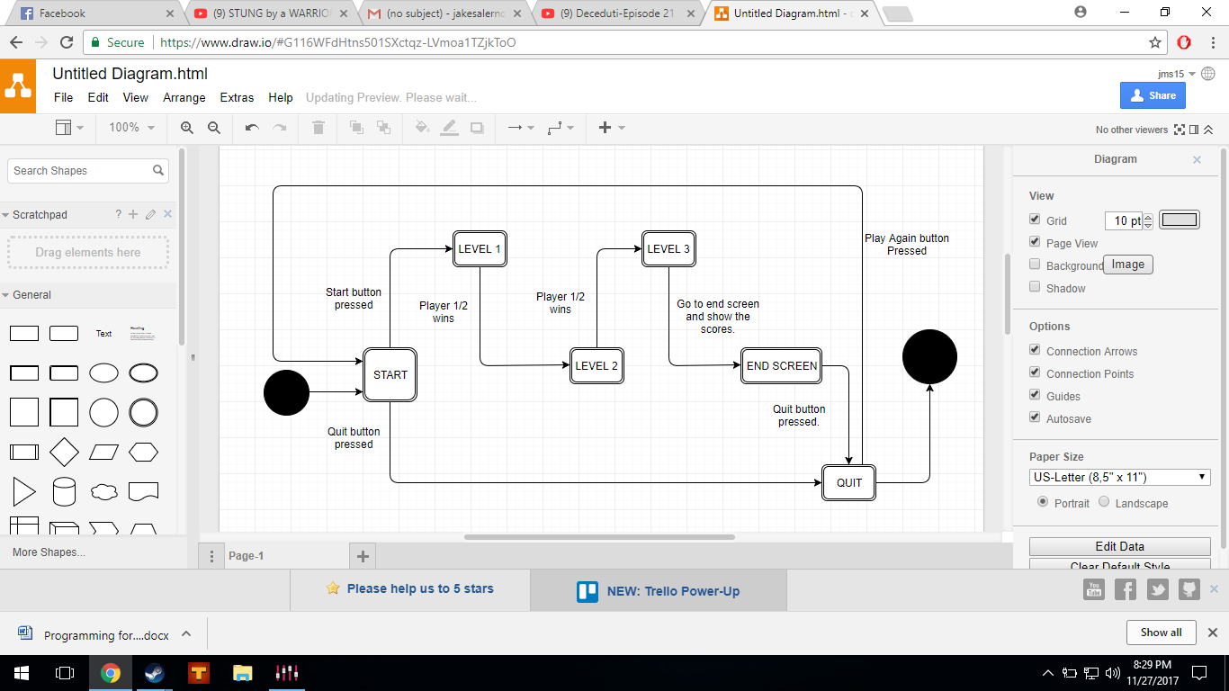

**Question 2B (Level 3):**

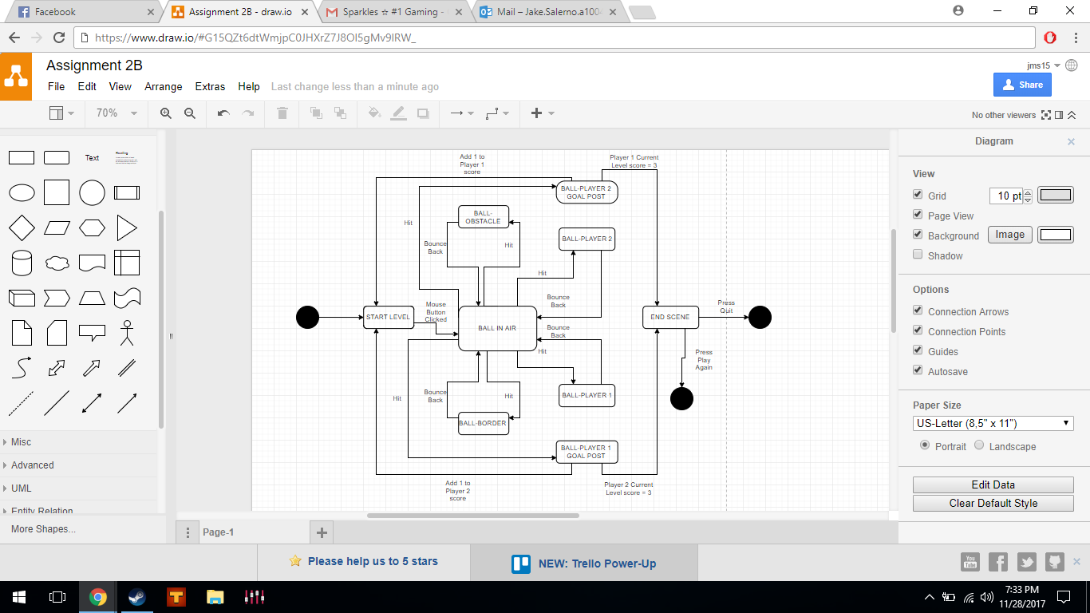

**Question 3:** According to Matt Mahoney, data compression is needed for saving time, reducing data storage, and reducing bandwidth. Data compression makes things possible, that before were impossible to make because of available hardware and storage. The two major compression classes are specialized lossy systems (such as JPEG or MP3) and generic lossless systems (.ZIP).

Internally, Unity utilizes a number of off the shelf systems. These systems are used for game assets such sounds, animations and meshes, to name a few. It goes without saying that these systems are important, as a product would require a considerable size of memory, particularly on mobile devices.